Viola Bak Lynch August 20, 1922 – March 13, 2001

Viola was born in Warren, Rhode Island in the home of her grandparents. She grew up in Cranston, RI and attended Valentine Almy School, then Briggs, and graduated from Cranston High. There she met her future husband, Robert Barrows Lynch of Edgewood. Their romance blossomed after graduation, when Bob was attending Brown University, while enrolled in the Naval Reserve Officer Training Program during World War II. Viola and Bob were married in Saint Matthews Church on April 10, 1944.

After the war, Viola and Bob took on the then unique challenge of restoring an old home located far from the madding crowd in Western Cranston, which was then located deep in the country. Together they raised two children, Robert Porter Lynch, and Richard Allen Lynch, while they lovingly restored their home.

Viola was a visionary and leader. In 1952, she founded the Cranston Junior Woman’s Club. Two years later she helped organize the Cranston Bicentennial. In 1957, she and her husband, both active in the Cranston Historical Society, played a major role in saving and restoring the Joy Homestead, located on Scituate Avenue. When the Sprague Mansion was to be demolished in 1964, Viola became a veritable crusader, leading the charge to purchase and restore the mansion as Cranston’s most illustrious and visible historic landmark. It is truly a living museum, and hosts numerous weddings, celebrations, and community events.

During the 1970’s and 80’s, Viola reached out throughout the state as the chairman of the Providence Preservation Society’s Consultant Board, providing guidance and expertise to hundreds of homeowners who were restoring old homes. In 1991, she and Bob turned their attention to managing the historic Nathaniel Porter Inn, serving elegant dinners and providing an example of the graciousness of New England hospitality to over one hundred thousand people who visited the Inn from all over the world.

She lived her life full of grace, and always gave in large measure, expecting so little in return. The world is a better place because of her spirit. And today we celebrate her life and her spirit that has blessed us all.
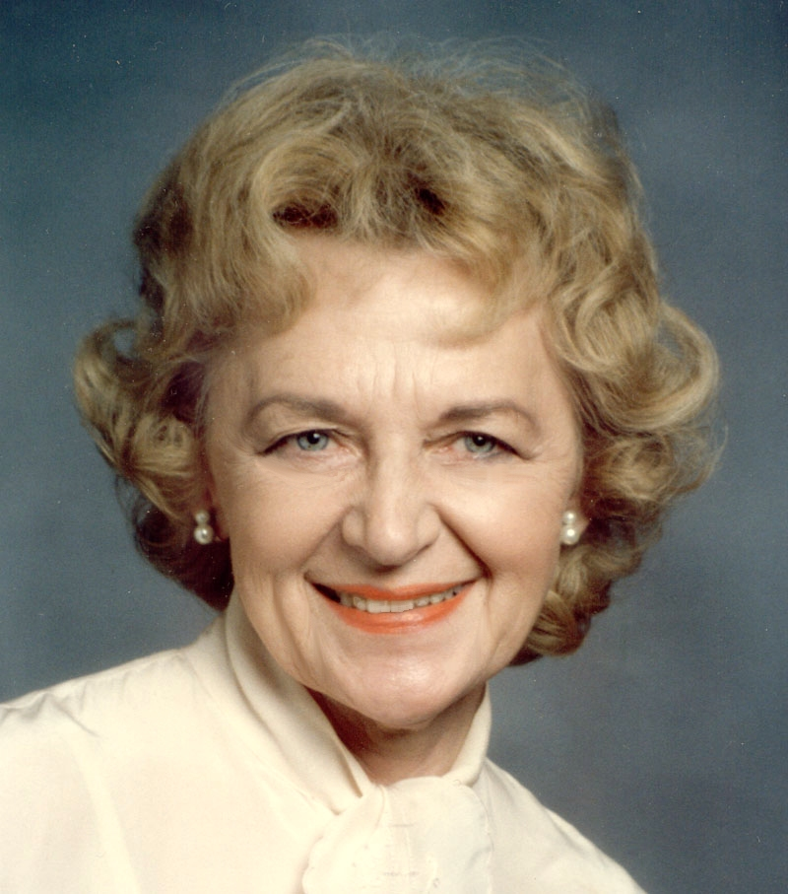
A Service in
Remembrance and Celebration
of the
Life and Spirit
of
Viola Bak Lynch
1922-2001
Central Congregational Church
Providence, RI
A Service in
Remembrance and Celebration
of the
Life and Spirit
of
Viola Bak Lynch

March 17, 2001 11:00 A.M.

Prelude
Surely the Presence of the Lord
Hear the Angels Sing

Call to Worship Reverend Rebecca Spencer

Invocation

Reading from Scripture Psalm 23

Words of Remembrance Lynch Family

You Belong to My Heart

Words of Remembrance Christine Vanacore

Ave Maria

Service of Prayer
Pastoral Prayer
* Lord’s Prayer
* Amazing Grace

* Hymn: Climb Every Mountain

* Benediction

* Recessional: Londonderry Air

* those who are able, Please Stand

*********************

Reception:
Following the Service, all are invited to a collation in the Chapel
Climb Every Mountain
(from the Sound of Music)

Climb Every Mountain
Search High & Low
Follow Every Byway
Every Path you Know

Climb Every Mountain
Ford Every Stream
Follow Every Rainbow
Until You Find Your Dream

A Dream that will Need
All the Love you can Give
Every Day of Your Life
For As long as You Live

Refrain
Climb Every Mountain
Ford Every Stream
Follow Every Rainbow
Until You Find Your Dream

A Dream that will Need
All the Love You can Give
Every Day of Your Life
For As long as You Live

Climb Every Mountain
Ford Every Stream
Follow Every Rainbow
Until You Find Your Dream

Guiding Principles of Viola B. Lynch
While she never wrote these down on paper, her life was always guided by these principles

- Community
- Always Work for the Greater Good of the Community: then Everyone Benefits.
- Always Give more than you Receive, it makes the world a richer place.
- Leave the World a Better Place than you found it.
- Leadership
- Don’t be Afraid of Tackling a Big Project you truly believe in;
- People will always work hard for something they believe in.
- Don’t Give Up just because times are tough and obstacles rough.
- Responsibility
- Do whatever Can Be Done, and Gracefully Accept what Can't.
- Keep the Highest Standards & Ethics Paramount in your life.
- Hold your Responsibilities as Dearly as your Rights.
- Love
- Seek Always to Bring Out the Best in Others;
- See beauty in every person, no matter how hard they make it to see.
- Treat everyone like Royalty, because everyone deserves respect.
- Keep a Positive and Caring Attitude; especially when others around you aren’t.
- Happiness
- Bring a Spirit of Joy to All.
- A warm hug is worth a thousand platitudes.
- Always greet people with a Cheerful Smile & Open Arms; it’s contagious.
- Friendship
- Always be there to support your friends and family, especially in the tough times
- To a friend’s house, the way is never long.
- Graciousness
- Graciousness begets Graciousness; Anger begets Anger.
- Always say “Please” and “Thank You.”
- Compassion
- Listen with Empathy and Compassion.
- Speak only the Truth; Otherwise be Silent;
- Neither Speak nor Spread any Gossip or Rumors;
- Forgiveness
- Forgive people; don’t hold a grudge: it just creates negative energy.
- Always Give People the Benefit of the Doubt.
- When wrong, Acknowledge, Apologize, then take Corrective Action.
- Complaining
- Don’t complain, unless you intend to take action on the complaint
- Dwell Not in Negativity; Complain Not about Petty Things.

