Robert Barrows Lynch October 2, 1922 – January 6, 2001

Bob was born in Danvers, Massachusetts, lived in Springfield, and moved to Cranston, RI at the age of six. He attended Cranston Schools on Commercial St., Shaw Ave. and Norwood Ave. and then Cranston High, graduating in the class of 1940. In High School, he was a baseball pitching star, and met his future wife, Viola Joan Bak of Auburn. Their romance blossomed after graduation, when Bob was attending Brown University, where he enrolled in Brown’s Naval Reserve Officer Training Program during World War II. Viola and Bob were married in Saint Matthews Church on April 10, 1944. Then Bob went off to the Pacific Fleet as a newly commissioned Ensign. During the war, on board the destroyer Harry F. Bauer, DM-26, his ship survived 13 kamikaze plane attacks, plus an unexploded torpedo as well as an unexploded bomb in the battle of Okinawa.

With a fervent interest in history, Bob collected antiques and helped bring our past vividly alive. After the war, Bob and Viola took on the then unique challenge of restoring an old home located far from the madding crowd in Western Cranston, which was then located deep in the country. Together they raised two children, Robert Porter Lynch, and Richard Allen Lynch, while they lovingly restored their home.

He and Viola then turned their efforts toward their community. Together they helped organize the Cranston Bicentennial in 1954. Then he focused the Cranston Historical Society on buying and restoring the Joy Homestead, which became the society’s first permanent home. When the Sprague Mansion was threatened by demolition in 1965, Viola acting as the crusader, and Bob, working behind the scenes as organizer, saved the home and grounds for posterity.

Bob was a visionary and leader in the Rhode Island Community, devoting much of his life to civic causes, serving on the Cranston Chamber of Commerce, YMCA, RI Bicentennial Commission, League of RI Historical Societies, RI Heritage Commission, and Providence Art Club. As founder of the Pawtuxet Rangers, Bob served as Colonel until 1996, participating in hundreds of the state’s ceremonial functions. In 1991, Bob and Viola turned their attention to managing the historic Nathaniel Porter Inn, serving elegant dinners and providing an example of the graciousness of New England hospitality to over one hundred thousand people who visited the Inn from all over the world.

He and Viola were both inducted together into the Cranston Hall of Fame in 2001.

He lived his life always giving in large measure, expecting so little in return. The world is a better place because of his spirit and vision. Today we celebrate his life and spirit that has blessed us all.
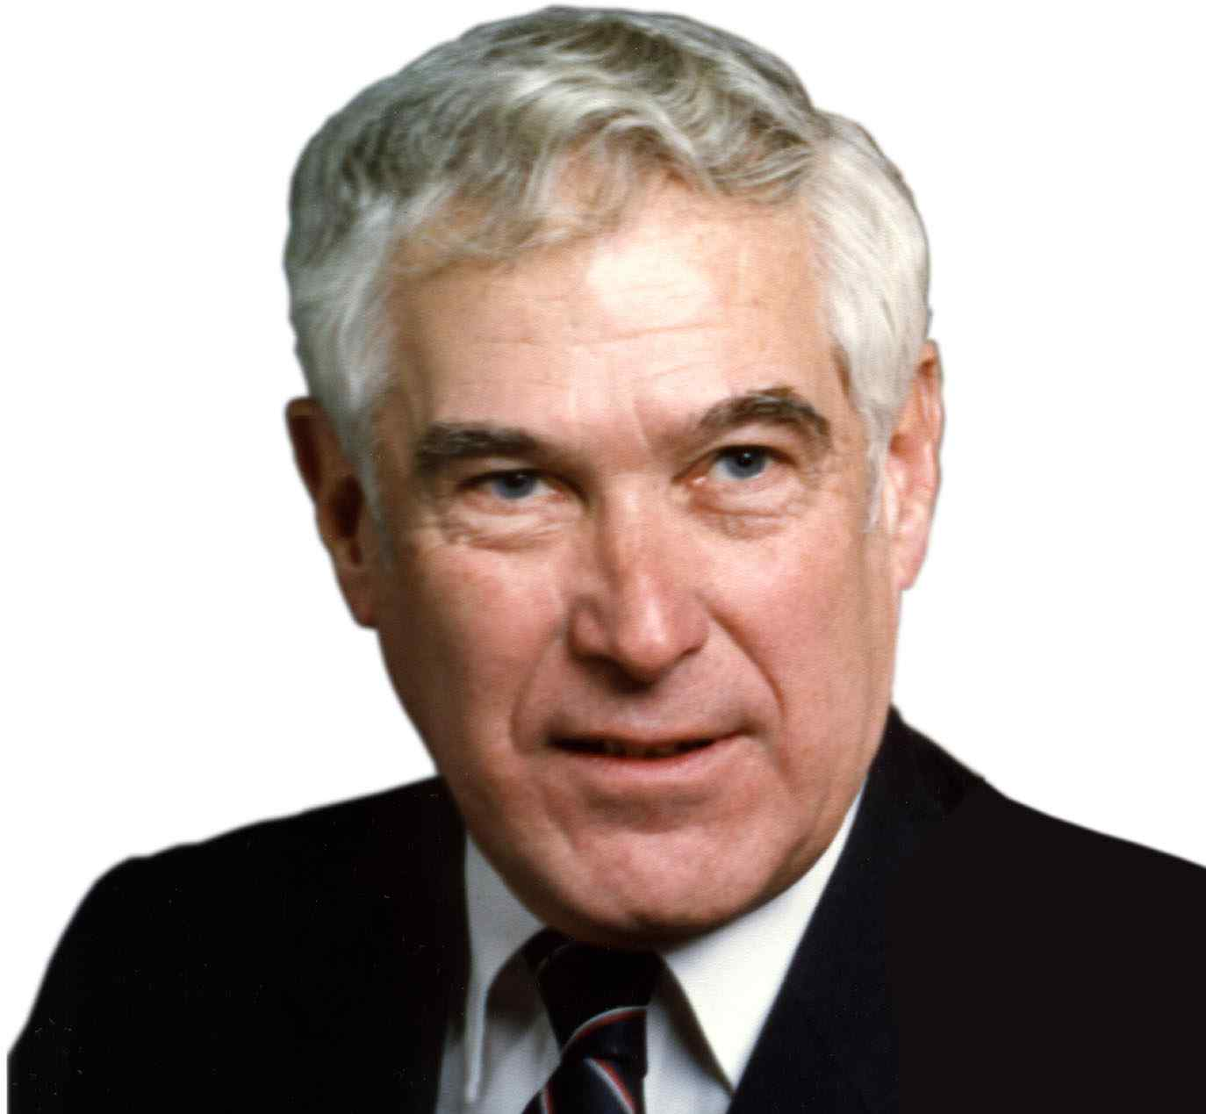

A Service in
Remembrance and Celebration
of the
Life and Spirit
of
Robert Barrows Lynch
1922-2003
Central Congregational Church
Providence, RI

A Service in
Remembrance and Celebration
of the
Life and Spirit
of
Robert Barrows Lynch

January 13, 2003 11:00 A.M.

Prelude

Call to Worship Reverend Rebecca Spencer

Invocation

Reading from Scripture Psalm 23

Words of Remembrance Lynch Family

You Belong to My Heart

Words of Remembrance Pawtucket Rangers

Staff of Nathaniel Porter Inn

Service of Prayer
Pastoral Prayer
* Lord’s Prayer
* Amazing Grace

* Hymn: Star Spangled Banner

* Benediction

* Recessional: Battle Hymn of the Republic

* those who are able, Please Stand

*********************
Reception:
Following the Service,
all are invited to a collation in the Chapel
Amazing Grace

Amazing Grace, how sweet the sound
That saved a wretch like me
I once was lost, but now I’m found
Was blind, but now I see.

‘Twas grace that taught my heart to fear
And grace that fear relieved
How precious did that grace appear
The hour I first believed.

Through many dangers, toils and snares
I have already come
‘Tis grace has brought me safe thus far
And grace will lead me home.

When we’ve been here ten thousand years
Bright shining as the sun
We’ve no less days to sing God’s praise
Than when we first begun

Guiding Principles of Robert B. Lynch
His Inner Core for which His Life was a Living Testament
- Wisdom & Learning
- Seek the Wisdom of the Ages, Honor the Codes of Our Forefathers
- Learn From History, Make It Come Alive
- Learn All Your Life: Develop Others by Passing Your Learning Along
- Responsibility & Standards
- Hold Your Responsibilities As Dearly As Your Rights.
- Set Your Sights High If You Want To Be Successful
- Keep The Highest Standards & Ethics Paramount In Your Life
- Goodness & Beauty
- Strive To Bring Goodness & Loveliness Into The World;
Women Are Especially Gifted To Create Grace & Beauty
- Be Patient with Others; Always Say “Please” And “Thank You.”
- Demonstrate Your Belief In The Inherent Goodness Of People
- Fairness & Integrity
- Earn People’s Respect by Treating Them with the Highest Respect
- Be Fair To All, Always Give Everyone the Benefit of the Doubt
- Be Sure Your Words are Your Bond, and Reflective in your Deeds
- Values & Character
- Values and Ideals are Necessary to Shape a Better World
- Always Do The Right Thing, Even Though Circumstance May Give
You an Advantage By Doing Something Less Than Honorable
- One’s Character & Values Are More Important Than Anything Else
- Tenacity & Perseverance
- Don’t Give Up Even When Times Are Tough And Obstacles Rough
- Stand Up For Your Values: Don’t Be Afraid To Voice Your Opinion,
Even if Others Don’t Agree; Protect the Interests of the Minority
- Perseverance Often Makes the Difference between Success & Failure
- Leadership & Vision
- Recognize & Take Action on a Good Cause Rally People Around
- Inspire People To Work Together As A Team;
Combining Honor& Caring to Bring Out the Best in Others
- Understand People’s Unique Psychological & Personal Needs
- Community & Country
- Always Give More Than You Receive
- Everyone Benefits When Working for the Community’s Greater Good
- Leave The World A Better Place Than You Found It.
- Navigation In Storms & Crises
- Always Keep Your Wits About You
- Don’t Burn Your Bridges Behind You
- Always Stay Focused, Keeping The Ultimate Objective in the Forefront

