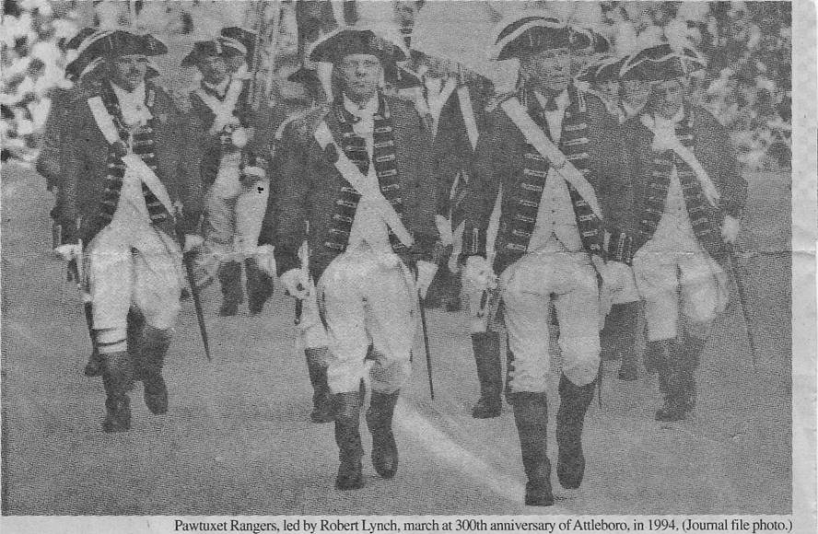
Pawtuxet Rangers. led by Robert Lynch, march at 300th anniversary of Attleboro. in 1994. (Journal file photo.)
A R.I. preservationist hero
PATRICK T. CONLEY

0

n JAN. 10, The Journal published the obituary of Robert B. Lynch. The one-column notice was minuscule when compared with Bob Lynch's volunteer contributions to the preservation and promotion of Rhode Island's heritage over the last four decades. Unlike the poor rustic in Gray's "Elegy," Robert Lynch merits much more than "the passing tribute of a sigh."
I met Bob in 1966, when he and his lovely wife, Viola, led a community-wide effort in Cranston to save the Governor Sprague Mansion from demolition. By that time, they had already rescued the Joy Homestead, in western Cranston, and helped to convert it into the headquarters of the Cranston Historical Society.
The campaign to preserve the Sprague Mansion was successful. I became a charter member of the building's board of managers, and Bob Lynch, a prominent Cranston businessman, was the unanimous choice for president.
In 1974, as I became chairman of the Rhode Island Bicentennial Commission ("ri76"), Bob espoused another cause: the revival of the Pawtuxet Rangers, a unit founded in 1774. The Bicentennial Commission helped fund the reorganization of the Rangers as a Rhode Island militia unit. Bob Lynch became its colonel and displayed his gratitude to the commission by offering the services of the Rangers for dozens of Bicentennial events.
Bob Lynch became so involved that he earned a seat on the state commission and the chairmanship of the Parades, Festivals and Re-enactments Committee of ri76. In that position, he supervised a host of Bicentennial pageants, including the parade that attracted over 100,000 spectators to downtown Providence. At this procession, Col. Bob Lynch led his scarlet-coated Rangers along the line of march as he had done in countless celebrations around the state and region, especially the Gaspee Days Parade.
Whether marching in Providence, Warwick, Bristol, Newport, Glocester, Pawtucket or outside state, Colonel Lynch made a memorable impression. Tall, erect, handsome, dignified, this World War II Navy veteran of Iwo Jima and Okinawa became the poster boy of the Rhode Island militia. His no-nonsense demeanor at the head of his unit recalled the seriousness of purpose that had motivated America's militiamen when these historic commands were first mobilized.
When the Bicentennial was over, Bob served as a volunteer member of the Rhode Island Heritage Commission, eventually becoming its president. He held that position in 1986, during its observance of the 350th anniversary of the founding of Rhode Island.
In addition to his statewide activities, Bob was for over 40 years a member of the Cranston Historical Society, and for several years was its president. He was also a vice president of the Cranston Chamber of Commerce, an officer of the Providence Art Club, a member of the Preservation Society of Newport County and a member of the board of managers of the YMCA.
Bob's Cranston High School sweetheart and lifetime partner, Viola Bak Lynch, embarked with him on another historic-preservation project when they were both at retirement age by establishing the Nathaniel Porter Inn, in Warren. They meticulously restored a rundown 18th Century house and operated it as a quaint inn and restaurant, whose excellence was extolled by Yankee Magazine and several history publications.
Though in their 70s, Bob and Vi commuted daily from their home, on Comstock Parkway, in western Cranston, to run their Warren enterprise. Among the inn's many patrons were National Guard generals, militiamen and re-enactors who reveled in the programs that Bob and Vi devised for their entertainment and cultural enrichment.
Less than two years ago, Vi Lynch succumbed to cancer. Bob was devastated. I saw Bob at Vi's funeral and several times thereafter. He was still courtly and gracious, but the spark of life had left him.
My wife Gail and I last dined at the Nathaniel Porter in November. In somber tones, Bob told us that this last preservation project was under sales agreement. "Vi and I," he said, "are calling it a day."
In December, I dropped by the inn, where the new owner said, -Bob will be here tomorrow" to pick up some things. I never saw him again.
If I were asked to name the 10 Rhode Islanders who had made the greatest volunteer effort over the last half-century to promote our state's heritage, surely Bob Lynch would be among them. Sadly, his obituary was as obscure as the past he had worked so valiantly to revive for the benefit of his fellow Rhode Islanders.
Patrick T. Conley, of Bristol, is a historian and rea1-estate investor.

