By Kristen Trahan – Staff Reporter
Pawtuxet Rangers Once Fought for the Crown

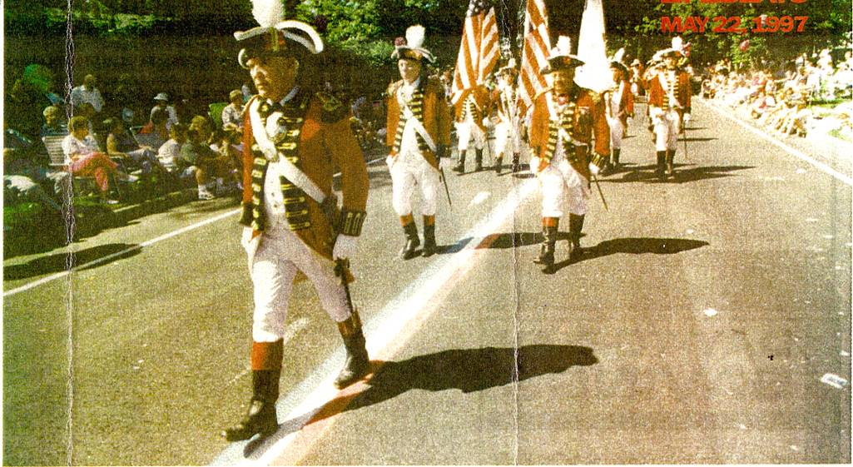
On June 7, 1772, Rhode Island patriots burned HMS Gaspee, a British revenue schooner, in the first armed conflict of the American Revolution. A little more than rive months later, the Pawtuxet Rangers Militia was chartered by the British government. Just over two hundred years after these events, the Rangers came full circle. Another Rhode Island patriot, Col.. Robert Lynch. brought the defunct Rangers Militia, a central part of the Gaspee Days celebrations, back into existence.
Head of the Parade: Col. Robert Lynch, recently retired Commander of the Pawtuxet Rangers, leads the militia in the Gaspee Days Parade.

Lynch was commander of the Rangers for 22 years, until his retirement last year. He is featured prominently, clad is the Rangers' red, on the Gaspee Days 1997 Calendar of Events. He looks historical, and he knows a lot about the history of the Pawtuxet Rangers. He has been active in the Rhode Island Historical Society, and is currently on the Board of Management for Gov. Sprague Mansion — affiliated with the Cranston Historical Society. He may or may not march in the Gaspee Days parade this year, but says he almost certainly will attend the festivities.
A salute as they go
"After all, I have to give them a salute as they go byl" said Lynch. He says he decided to step aside after last year to let others come along. The Rangers' new commander is Col. Fred Hoist.
"It's been a very enjoyable time," Lynch says of his command. "but I've got to move over. It's one of those mixed emotion things.'
Lynch says he got involved with the Gaspee Days celebrations after reforming the Pawtuxet Rangers Militia back in 1974. His fascination with history, and his participation in World War II, led him to revive the defunct militia.
"I'd always been interested in history, even as a kid," he said.
Lynch was in the Navy in WWII, stationed aboard the destroyer Baur in the Pacific theatre. He was witness to the battles of Iwo Jima, Okinowa, and the Philippines. His ship was subject to frequent
kamikaze attack. He told a story of one plane which landed on the deck of the Bauer. The plane's bomb did not explode on impact, and became lodged into the ship. It was 17 days before the unexploded shell could be removed.
"You never forget a thing like that," he says of his military experiences. "The Rangers were an extension to study military history on an active basis."
After researching the matter, the Rangers were revived under their original 1772 charter. The Gaspee Days committee formed a Fife and Drum Corps in 1972, and they were integrated with the militia in 1975.

"We agreed to combine the two," said Lynch, recalling the beginning of the relationship. "Now it's pretty much back where it ought to be."
Though Gaspee Days is the high point in the year for the Rangers— they are slated to participate in a colonial encampment in Pawtuxet Park, a parade, and a colonial muster June 13 and 14— 1.y nch says they are active year round. They participate in parades, battle reenactments and encampments throughout the summer, and they visit schools to teach about that long ago time when Americans rebelled against colonialism.
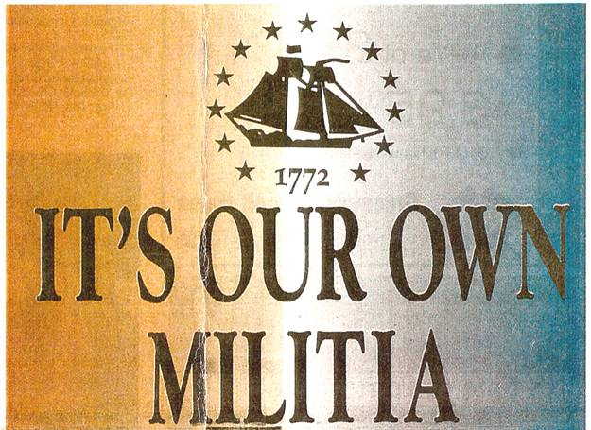
"They carry out things that perpetuate history," said Lynch. "We tell them (students) about history in detail that teachers aren't necessarily expected to know."
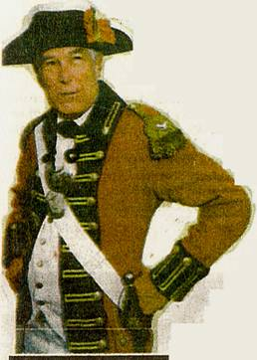
The Rangers were granted a charter by the British government back in 1772 for local protection. The British would not allow a colonial army—but they did permit militias, in part to protect their own local interests. At the time they were formed, the Rangers were expected to be protection against French and Spanish raiders. and against the Indians. They ultimately participated in the battles of Rhode Island, Saratoga and Yorktown against the British. Later they became the Pawtuxet Artillery, fighting in the War of 1812.
"That era was a booming era for the militia," Lynch says of the Revolutionary War period through the mid-1800s. "It was still a method of defending the country,"
After 1849, however, interest in the militia declined. Lynch says the Pawtuxet Armory became a Masonic Hall named Harmony Lodge. Sometime after that, it became a private home. It was not until the early 1980s that the Rangers purchased the Armory to return it to its intended use.
An often-asked question of Lynch has to do with the color of the Rangers' uniforms. They are red—similar to the uniforms the British army wore during the Revolutionary War.
"We were British," says Lynch of the Rangers' Militia. "We copied the mother country's uniform. We were loyal subjects of the crown for many, many years—you don't throw that away in a day."
The fact is, many militias wore a red uniform at the beginning of the Revolutionary War. The traditional blue uniforms, usually depicted in paintings of the time showing the colonists fighting the British, did not come until later.
"We teach a lot of history from that one alone, said Lynch.
Lynch jokes about the fact that the Rangers, due to their red uniforms, are usually cast as the "had guys" in battle re-enactments.
Although Lynch has significant knowledge of the history of the Rangers, he says that one does not need to be an expert to join. He says the Rangers recruit mainly through word of mouth.
"Usually someone expresses an interest, and you follow up on that interest," said Lynch. "But we don't just take anybody."
The Rangers look for good citizens. That, says Lynch, is the most important qualification. He says that some people are under the impression that in order to join the Rangers one has to have a lineage "dating back to the Mayflower" or an extraordinarily firm grasp of Revolutionary War-era history. He says none of those things are true.
"A person can come into the Rangers not even knowing what a uniform looks like—an interest in history is good, but not imperative," he says. "As long as they're honorable people — that's the most important thing you can have."
He says that many people join the Rangers to socialize, and to make a contribution to the community.

Young-uns are welcome

"It's a well respected group of people. We've contributed to the spirit of the community, and I think we've been honorable," said Lynch. "We've been able to engender self-respect."
He says that even young people are encouraged to join—the earliest age for participants in the Fife and Drum Corps is 11, and the earliest possible age for the militia is 16.
"The family is very much involved," said Lynch. "The more family you can get involved, the better."
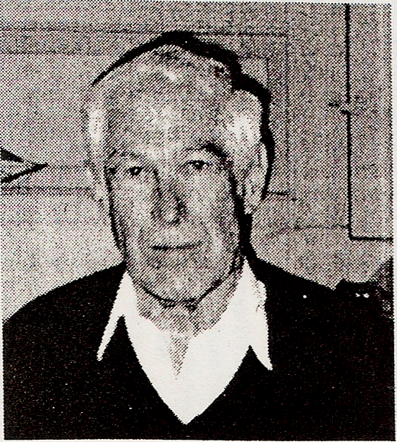
Far from simply being a quaint historical entity, the Rangers are a legitimate military order, sanctioned by the state, in the modem age. Lynch recently testified before the Veterans Affairs Committee of the General Assembly regarding a bill that concerns the 13 member Rhode Island Militia, of which the Rangers is a part. The bill would prevent any militia group operating without the state's authority from using the name Rhode Island Militia. Such a bill is necessary, says Lynch, to differentiate between the legitimate militia groups in Rhode Island — those supportive of the government — and those militias who would disassociate themselves entirely from the govemment.
Rangers were an extension to study military history on an active basis." — Col. Robert Lynch
"Those so-called militia companies have no legal authority at all," said Lynch of the groups such as the one in Texas, recently in the news. "We do something that is quite different."
Lynch says the sanctioned militias have always operated under a charter— first from the colonial and then the state government. They work in concert with the government—not against it. He calls the recent rash of illegitimate militias "worrisome", but does not think they will continue to be a growing problem.
"I'm enough of an optimist to think the world will wake up and straighten itself out," he said.
Until that time, the Pawtuxet Rangers Militia and Fife and Drum Corps will continue to serve the community, and remind us of the past.

