April 18, 2001
Summary of the Olszewski and Stachowiak Families
By Bernard A. Stack, Sr (Stachowiak)
1 Hall Street, Warren, RI 02885
Born November 28, 1911

My Grandfather, Joseph Olszewski, 1850-1925 came from a village named Zablotne Skotniki (muddied cattle) later named Piecin (or Piecki), which is located several kilometers east of Kruszwica, which is north of Konin (pop 20,000). The town that he emigrated from, Stawsk, is very small, located 4 km (2.4 miles) north of Kruszwica (Konin is located west of Warsaw, on route E-8) From Konin, you travel north on route 165 toward Inowroczlaw. Stawsk is about 4 miles south of Inowroczlaw. Kruscwica (8,000 pop.) is 6 miles SE of Slawsk.
Central Poland
N
S
Not Drawn to Scale
Bydgoszcz
Inowroclaw
Torun
Slawsk
Kruszwica
Village
Skotniki
Zablotne
(muddy Cattle)
(Old Name)
Today called Piecki
Kleczew
Konin
To Poznan
To Warsaw
25 miles
4 miles
30 miles
4 km
Several km
25 miles
12 miles
110 miles
55 miles
Village from which Jozef Olszewski migrated to USA in 1888, Birthplace of Katarzyna Olszewska
Home of Anonina Olszewska Janczak Pop. 8000, 1980
Origin of Olszewski Family on Large Farm
60 miles
4 miles
Mikolajewo
Rural Area Original Farm of Stachowiak Family (son in law Janslaw and Mary Przybylski Present occupants May 1976
Bernard Stack (Stachowiak), 1981

The area of Poland is 126,000 square miles, equal in area to all New England, plus NY and NJ. 502 miles from NW corner diagonally to SE corner.

Jozeph Olszewski, age 38, in 1888, decided to migrate to the USA. His family consisted of his wife Agnieska Lewandowska Olszewska, age 38, and three daughters – Katarzyna (Katherine), b. 1879, Pelagia, b. 1881, Salomea b. 1886, two step-sons from Agnes, who had been married to a man named Mila. The step sons were Mickat (d. 1908), and Jozef Mila, who later worked in Chicago as a baker. The seven of them left Poland, probably by train and traveled to Hamburg where they boarded a steam ship and traveled about 11 days in steerage to N.Y. City (past the Statue of Liberty) around December 1888, disembarking at Castle Garden, near Battery Park. (Ellis Island, as a receiving station, was not opened until 1892.) Grandpa Olszewski had a sister Maryanna (1858-1943) who had emigrated to the US at an earlier date and had a disastrous experience at Castle Garden. Her infant daughter was kidnapped while they were was on the dock and the child was never found.

The Olszewski group traveled by train to Quidnick, RI and were received by grandpa’s sister, Maryanna Rybarczyuk at their home. The Olszewskis settled in a mill tenement, which was a duplex house, 1 ½ stories, side by side units. I remember the house, since demolished, was on an elevated lot, 3 feet above the sidewalk and had a stone retaining wall in front. It was on Quidnick street on the east side, second house from Washington Street and across from the mill.

The side-by-side tenements remind me of a story my mother told me about living in a similar house in Warren. Her niece lived in the adjacent section of the house and the pantry wall was common to both. To facilitated contact and communications, they punched a small hole in the wall, (also handy for one cook to ask the other cook if she thought a sample spoonful of soup was seasoned sufficiently).

In 1904 Grandfather Olszewski bought two adjacent Cape Cod type cottages at #527 Washington Street, Quidnick, R.I. for $2,000, and they lived in one and rented the other. The houses are there today. In their earlier days they were well maintained. Grandpa’s house was fenced in and was 1 ½ stories high, had a broad front porch and was on a large (1 acre) lot; across the street there was a trolley track, a fence, and then there was the west branch of the Pawtuxet River with a big steel railroad span bridge crossing the river. The bridge was about 35 feet above the river and boys in the river swimming would jump off. We often fished there but I cannot remember catching very much.

The house had no running water or electricity. In the kitchen was a black sink with a cast iron water pump at one end. Downstairs was a living room, dining room, and kitchen. Upstairs were 3 or 4 bedrooms (small). In the back yard was the outhouse; on the wall hung a calendar from my father’s grocery store and I thought it was sacrilegious to have a Stachowiach calendar in such an uncouth place. Also in the back yard was a large tool shed and another building for storage of firewood, pigeon loft, etc.

I remember the cellar was dark and cold with a dirt floor and had massive stone steps coming down the cellar bulkhead. I always remembered a large coil of garden hose on the porch floor and as a kid I wanted to squirt water but I don’t remember any water pipes or running water. The cellar was cool in summer and fresh food was stored there temporarily to prevent spoiling.

I remember Aunt Stasia’s wedding. We boys went down cellar and swiped a container of ice cream and went to the river bank to give the ice cream the attention it deserved and not having spoons or dishes, we had to eat it with our bare hands before it melted.

Amusement in Quidnick was lacking Fishing, swimming (sometimes at Salt Water – Nausauket Beach), blueberry picking, etc. There were no street lights and on a dark night grandpa would take a lantern and his accordion and take a group to go visiting and sing and dance. Grandpa was a robust tall man with a well poised carriage. He had white hair and a gay-nineties moustache, light smooth skin and on cold days his cheeks were red. He was a religious man, a trustee in the founding of Our Lady of Czenstochowa church. In his retirement he attended mass daily in his nearby church. On days when there was much snow and the altar boys did not show up, he served as altar boy himself.

The Olszewski family had a cemetery lot on top of a hill on Gough Street. In 1908 his granddaughter Rosalice Szylkowski was killed when she went to Dyer’s Store nearby for ice cream, and when she ran out of the store, a street car struck her as she stepped out of the doorway. She was buried in the Olszewski lot. A few days after the burial, grandpa’s step son, Michael Mila, died suddenly in Boston where he was working at a ladies clothing tailor shop. The shop owner had no information of his kin and one of Mila’s co-workers remembered that Mila had told him that a young niece had been killed recently in Rhode Island by a street car. This gave a clue of his kin and his remains were brought to Quidnick for burial. He had some money saved and his heirs used it to erect the family cemetery monument.

I vividly remember my mother getting her five children ready to go from Warren to Quidnick for a holiday such as Easter or Christmas. She got us all cleaned up and dressed up for travel and we had to sit still until the last one was prepared. Then we walked to the Warren Depot and took the electric train to Providence. In winter we took the steam train, Providence to Quidnick, but in the summer time we road the open-air trolley cares which had long benches cross-wise and we all got car-sick and had to go to the back platform where we could relieve ourselves unobserved. My father didn’t come until later as he had work to do at the store before the holiday.

The cemetery lot appears to be about 16’ x 10’ and contains the remains of 11 adults and one child.

My mother was the oldest of 5 daughters and married Joseph Stachowiak in 1895. She was married by a Polish Priest in Quidnick (Rev. Chmielinski, of Webster, Mass.). The wedding party walked from the Olszewski house to St. John’s French Church, ¾ mile, and my mother’s wedding dress was a pale green ribbed silk material of which I have a small swatch.

His sister, Maryanna Rybarczyk, moved to Warren, R.I.. She was an expert seamstress and she sewed children’s clothing that her daughter Pelagia sold in her dry goods store. This project grew until Pelagia built a large brick building uptown in Warren. The store sold yard goods and ladies wear and was very prosperous. Pelagia employed three clerks to handle the volume of business.

Grandpa Olszewski had an imposing bearing – tall, straight, and dignified. When Grandpa went to visit his sister he always put on his black suit, got out his gold stickpin for his necktie, then he would ask my mother for some perfume which he rubbed into his palms, brushed his palms through the hair on his temples and fnally rubbed his hands on his back side and then he was ready to go.

For wedding gifts to his daughters, he gave each a karat gold ladies’ lapel watch with a gold snap cover. I still have my mother’s.

Grandpa had another sister who married a man name Michalski. He was at the Columbian Exposition in 1892 and a land agent sold him some land in Three Lakes, Wisconsin. The couple traveled to the area in North East Wisconsin. He built a cabin and cleared land for farming and soon a new railroad was built on land he sold to the railroad. He prospered. The wife had previously run a ladies’ clothing tailoring shop in Chicago.

Grandpa often used an expression that I could not fathom. If you related to him a story of local news or history, when you finished he would say in Polish, “ah niech zyue za?z!”, which translates to “Oh, to be without life, immediately!” I could never fathom what it was to convey. Probably a group of meaningless words as we say today: “Oh, you don’t say.”

My parents came to live in Warren, R.I. in 1895. My mother went to school for one day in Poland. That evening her father asked her what she had learned, and replied “Ein-zwei drei-vier” and that was the beginning and ending of her formal education.

My father didn’t like factory work, so in 1902 he opened a grocery and butcher shop. He never went to school. When he was 9 years old, he had a job in a brick factory, and later he worked with a group of itinerant slaughterers and butchers who traveled through their neighborhood. Han ran the store until 1917, when poor health forced him to close. Without schooling he taught himself to read and write and figure his accounts pertaining to the store. For a hobby he liked to write patriotic verse about Polish history. He hated Bismarck (contemporary German Dictator and oppressor of the weakened Polish country. He was a trustee of the St. Casimir’s Church in Warren. When Reverend Peter Switala came to Warren in 1908 to organize the new church be boarded with my mother, She had 4 children, but was able to take care of his lodging.

My mother had a niece “Bronia” in Quidnick who had a boy friend in New Bedford, Mass. He courted her many weekends. When would leave New Bedford after work on Saturdays, he’d ride his high wheel bike 43 miles (one way) to Quidnick, and return to New Bedford on Sunday afternoon over rough unpaved roads. He was a powerful giant of a man and very handsome.

For a time the Sydlowski family lived in Warren at 48 Baker Street. William Sydlowski was born in Warren.

Historically, I made a discovery. At home we had pictures of the Janczak family in Poland. We had not heard from them for many years. I wrote a letter to the Janczak Family in Kruszwica, address unknown. I was much surprised to receive a reply, much more than I expected. A letter was written to me from
Donsualda Janczakowa
UL. Swierczewskiego 38/3
88-150 Kruszwica, Poland
He was approximately 58 years old (born 1943) when I received his letter in 2001.
Donsualdo’s grandmother was Antosia Janczakowa. She was the youngest sister of Joseph Olszewski. She married Antoni Janczak, a baker, who had his shop in Kruszwica. She had 14 children, 12 boys and two girls. Those of her sons perished in WWII. During WWII the Nazis confiscated all the equipment in the bake shop and the business never revived. Donsualda has inherited all the historical records of the family. She worked in a sugar factory (sugar beets) and recently completed a correspondence course in organic chemistry. I corresponded with her and made plans to visit her. She offered to come to Warsaw airport to meet us. Unfortunately, marital law came into the picture in Poland and we decided not to take a chance in Poland. When I notified Donsualda (apparently a sensitive person) she was greatly upset and our correspondence has ceased.)

Our mother Katherine never went to school except for one day. She could read and write Polish and her reading English was very limited. During WWII, General Embargo was often being spoken on radio broadcasts of news and she was curious to know who was this Italian named General Lombardo! She learned to speak English well enough to be able to interpret for Polish men and women in doctor’s visits and in court. When in court a sexual episode was being tried, her English vocabulary was limited, so she translated the Polish equivalent into English and it came out “do a damage to her.” Attachment became “toochman” which was very amusing to the court. Here oldest daughter, Pelagia, born 1899, was unable to understand or speak English when she entered the 1st grade because she had only spoken Polish to her parents. She soon learned to participate in her studies without “English as a second language” instruction. Soon she received all “A”s in her English classes. She could play the piano just by listening to the tune, no musical sheets. Her father never went to school but was able to do his figuring at his store, while employing three assistants. He was a versatile mechanic, butcher, sewing, made shoes and leather boots, masonry, carpentering, sausage maker (sour kraut and dill pickles) farmer; we had a pla? at home, collector at church, and church trustee, also a horseman.

My mother was very proud in 1912. She had borne 8 children, 5 survived, 3 died in infancy due to lack of proper refrigeration for milk. She had a new house built with 10 rooms for herself, 5 more rooms to let, and was only 33 years old and she had finished raising her family. Today the schedule is very different.

Stachowiak on index cards in Library of Congress, Washington, DC

Antone, 1911 German Book, Poznan, 1950
Franz, 1979, German Book, Munich
Hans, Mathematics
Herbert, 7 volumes, mathematics, Vienna
Jerzy, Elections, 1964
Lech, Fibre Study
Stanislaw, Law
Wtadystan, Man, origins

Stories remembered by Robert Porter Lynch, son of Viola Bak Lynch, daughter of Pelagia Stachowiak Bak

My mother was born on August 20, 1922 in the Triple Decker house on Union Street in Warren. Although her mother, Pelagia, was living at 5 Legion Way in the Auburn section of Cranston (near the City and the fire station), Pelagia went to her mother’s to give birth.

Viola would ride her bicycle from Cranston to Warren on the weekends to visit her Grandmother. Her Grandfather, Joseph, was always fixing things around the house. As he grew older, he did not want to relinquish any of his time-honored responsibilities. During the Great Depression of the 1930’s the roof began leaking quite badly. With money extremely scarce in that era, he vowed to do the repairs himself. However, the roof was very steep, and he was getting frail. So he clamored cautiously up a three story ladder, and climbed up onto the roof with a rope tied around his waist. On the other side of the house his wife Katherine had the other end of the rope tied around her waist, so, if he slipped, she would prevent a fall. He put a new roof on the house in close liaison with his wife.

Joseph operated a butcher shop on west side of Water Street between Sisson and Company Streets. During the early 1930’s, my mother recalled visiting the store and there was a busy flow of people in and out. She remembered the old pickle barrels, the wooden counters, the wooden crates of soda, and the jars of candy. Every once and a while the local policeman would drop by; he would go into the back room with her Grandfather, and emerge with a big smile. For years my father speculated that Joe Stachowiak was making bathtub gin, something my mother would vehemently deny, vigilantly upholding her grandfather’s reputation.

About 1986, I while I was restoring the Nathaniel Porter Inn, I was walking down Water Street, and old man Ginalski, who lived near the corner of Water and Johnson Streets was sitting on his front steps. We struck up a conversation, and when he learned that Joseph Stachowiak was my Great Grandfather, he piped up:

“Yeah, I knew your great grandfather. He had the store just down the street. Let me tell you a story I remember like it was yesterday. One day my mother sent me to his store to buy some things and a couple of bottles of Coca Cola. When I went to the wooden rack where the Coke was and pulled out two bottles, old man Stachowiak came running over and hit me hard on the knuckles with a stick. I yelled and went running home and balled to my mother. She was furious and came storming into the store to confront him for hitting me for no reason at all – she thought I was totally innocent. After she chewed him out for a few minutes, your Great Grandfather went over to the Coke rack, and politely pulled out two bottles of “Coke” and asked ‘Since when is Coke clear?’ Your Great Grandfather was selling booze, just like everyone else on this street. That’s why we’ve had so many bars on Water Street. They never went out of business during Prohibition.”

My Grandmother, Peggy (Pelagia) recalled that during Prohibition there was a constant stream of people coming into Warren from the Fall River train. She observed that they carried suitcases as they disembarked, but oddly there were only a very few hotel rooms in town. She also said, quite quizzically, that their suitcases were always seemingly empty and light when they entered town, and burdensomely heavy when they got back on the train.

When I told my Aunt Gene, Peggy’s sister, the story, Gene said: “Oh, they were all coming into town to buy liquor here. Everyone sold booze on Water Street. You see, they had Prohibition in Massachusetts, but we didn’t have it here in Rhode Island!” Peggy was always a bit naïve or overly protective of her father’s reputation. My father’s speculation was right.

In 1975 I was with Eddy “Rip” Higgins in his living room, and I brought up the problems of the bars on Water Street. Rip was the chief of staff for Theodore Francis Green for Green’s entire political career. Rip told me the story of how Warren was a rum-running central drop-off point, especially because of the amount of waterfront. He said:
“One night I got a phone call in the state house. The G-men had a tip there was going to be a landing of booze on the Kickemuit River. So I drove back to Warren to get a front row seat on the raid. When the rum runner came up the river and began landing the boxes of bonded scotch on the shore, the G-men closed in and arrested everyone. They then took the scotch on a truck to the Warren Police Station to put the booze under lock and key in the Jail. I watched as the loading party would put the first box in the jail cell, but the guys with the second box went past the jail door, around the back, and put the booze on another truck. Every other box bypassed the jail.”
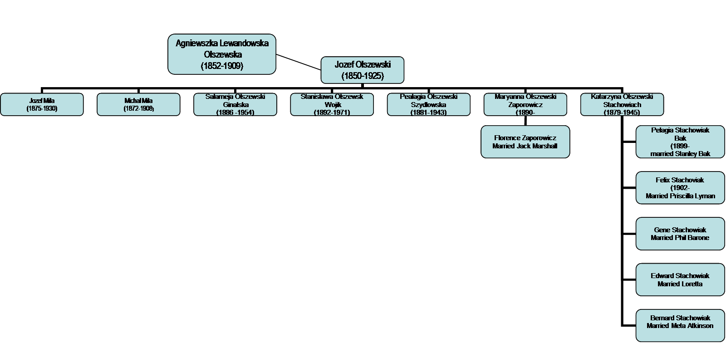
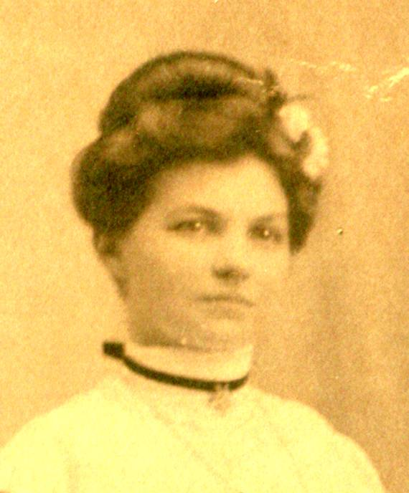
Family Tree
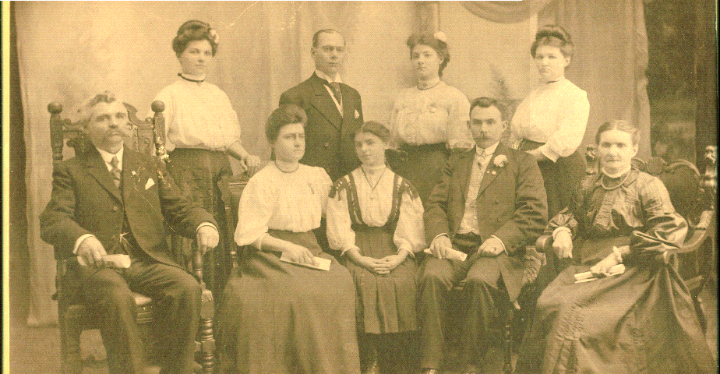
Katarzyna Michael Mila Maryanna Pelagia
Jozef Olszewski Salameja Stanislawa Jozef Mila Agniewszka

