THE LADY WHO SAVED
the SPRAGUE MANSION
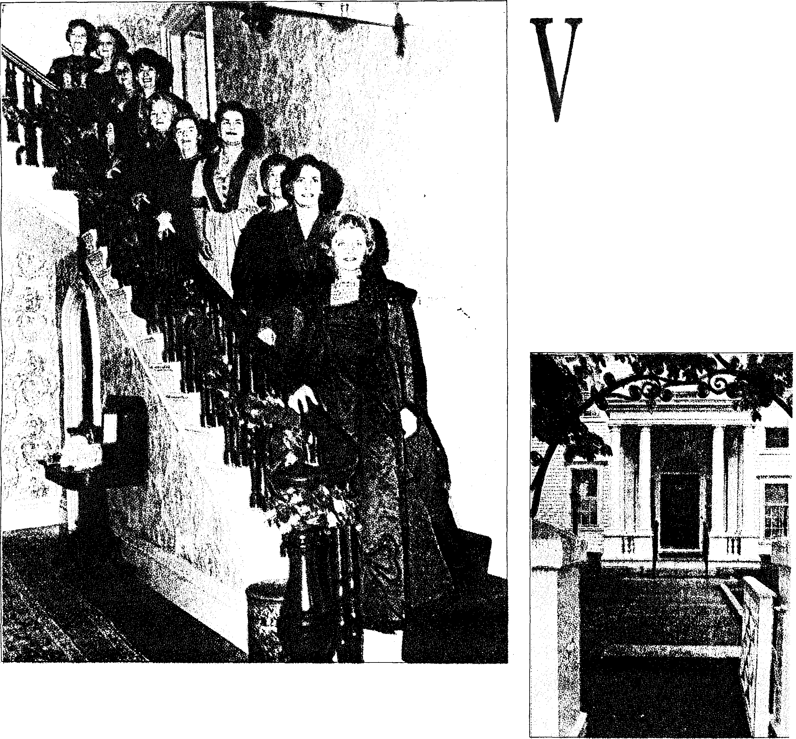
Story by Barbara Polichetti – Journal Staff CRANSTON
Photo above from Images of America: Cranston
BEST FOOT FORWARD: Viola Lynch, right, and other members of the Cranston Historical Society pose on a staircase of the Sprague Mansion in 1967, during the first Christmas open house held there. Thanks largely to Mrs. Lynch's efforts, the mansion escaped being razed to make way for a high-rise apartment building. In the Journal file photo at right, a view of the front entrance of the mansion.

V
iola Lynch was voted the prettiest girl it her class when she was in high school. She married at age 21, raised a family of two boys and became a historic preservationist. About 10 years ago, at a time in life when most people are thinking of retirement, she and her husband, Robert, took over as innkeepers at the Nathaniel Porter Inn, in Warren.
The couple became well known as gracious hosts, and were appreciated for their entire family's work restoring the 18th-century building and revitalizing it as an inn by instituting such popular traditions as Christmastime Yule Log celebrations and Twelfth Night dinners.
And Viola Lynch's place in local history was secured about 35 years ago when she led the charge to spare the historic Sprague Mansion fron being reduced to rubble to make room for a high- rise apartment building for the elderly.
Mrs. Lynch, who died last week at age 78, will forever be known in the city as the lady who saved the Sprague Mansion.
It was a mission that took thousands of dollars and the dedication of many residents, but Viola Lynch was the spark that ignited the movement that resulted in the city's preserving the sprawling white Colonial- style mansion on Cranston Street that is now its most prominent historical property.
"A lot of people put in a lot of work," Robert Lynch said this week, recalling the preservation campaign. "But it was always Vi's project from the start — she kept the pot boiling."

He said it started in 1966 when one of her many friends informed her that the city had received federal money for the high-rise apartments and was going to tear down the stately clapboard house that had been home to two Rhode Island governors.
Concerned that history was about to be destroyed and that her home city had no major tourist attractions, MrS. Lynch put down a dainty foot and decided that the city's plans would simply have to be scrapped.
Robert Porter Lynch, one of her sons, likes to recall that his mother's intervention came just as Mayor James DiPrete Jr. was in Washington firming up the federal money for the new apartment high-rise.
Informed by a staff member that a woman back home planned to fight the project, the mayor later recalled, he anticipated having to face off against a formidable advocate who would look like ax-swinging temperance leader Carrie Nation, Robert P. Lynch said.
He said that the mayor was therefore quite pleasantly surprised when his mother, a petite blonde with blue eyes and a penchant for wearing high heels, met him at City Hall.
"The mayor was enthralled," Robert P. Lynch said, adding that DiPrete had also met his match. "She always had a smile on her face, but she would never take 'no' for an answer."
Her husband said that the first step was to get a reprieve from the U.S. Department of Housing and Urban Development. Not surprisingly, he said,
After that, he said, committees were formed, city officials jumped on the bandwagon and there was an all-out fundraising effort to save the mansion.
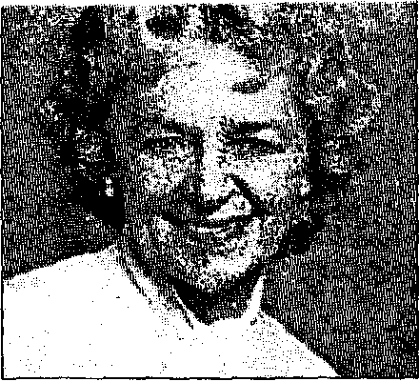
Everybody had a job to do, Lynch said, and Viola's was to do what she did best: be the spokeswoman.
Family photo courtesy of Robert P. Lynch
VIOLA B. LYNCH
She had the presence, she had the charm," Lynch said. "It was her face that the public saw."
The campaign to save the Sprague Mansion eventually became so big that it encompassed most of the city, Lynch said. There were billboards. There were church-sponsored fundraising suppers. There were children throughout the city towing little red wagons as they collected and sold old newspapers so that they, too, could make donations.
Students at the Lynches' alma mater, Cranston High School — later Cranston High School East -- used the image of popular cartoon hero Batman in a fundraising drive. At one point, Lynch said, they draped a huge banner across the school which, in comic book parlance, questioned, "Can Batman Save the Sprague?"
In the end the mansion was saved, purchased by the Cranston Historical Society for about $125,000, Robert Lynch said.
He noted that his wife did not miss a beat, and immediately set about the task of finding ways to furnish the home's 28 rooms with historic pieces.
ALTHOUGH VIOLA LYNCH
has been publicly lauded for her work as a preservationist, history was not always her passion.
Raised in the Auburn section of Cranston, Viola Bak fell in love with history when she fell in love with Robert Lynch, a former classmate from Cranston High School.
Robert, a history buff since childhood, said that he and Viola were pals in high school but didn't start dating until he was a student at Brown University. He said he saw her one day at Bonnet Shores Beach and told himself at that moment, "I'm going to marry that girl."
They married in April 1944. Shortly afterward, Robert Lynch was sent off to war with the Navy.
His ship stopped once in Hawaii, he said, and he sent grass skirts and colorful tops home to Viola with the request that she wear them and send him photographs. Family pictures show the smiling young wife obligingly posing in the native costumes, complete with flower leis, and not seeming to mind that in one photo she is barefoot in the snow.
An independent thinker with the warmth and charm to turn strangers into friends, Viola Lynch was still very much a traditional wife who supported her husband's endeavors, said Robert Lynch, a retired manufacturing the wilds of Western Cranston when he found an old farmhouse that dated back to the early 1700s.
The couple lovingly restored the Comstock Parkway home, known variously as the John Burton house and Chestnut Hill farm. They raised their two sons there, holding huge Thanksgiving
dinners before a roaring fire in the old keeping room. All around the property, Viola and her mother- in-law planted flower gardens that bloomed amid lilac and mountain laurel bushes.
Robert P. Lynch, who eulogized his mother last week, said that her love of life and her kind spirit infused their everyday lives. He remembered her gardens, her friendships and her tolerance for the seemingly never-ending parade of pets and "critters" (including a turtle and a skunk) that he and his brother, Richard Allen Lynch, always seemed to be bringing into the house.
An old schoolhouse slate-board hung in their kitchen, he said, and on it his mother had written the creed: "To a Friend's House the out a list of "guiding principles" that Viola lived by. The list includes phrases that summarize Viola's beliefs on everything from friendship and graciousness to compassion and commitment to the community.
"She was elegant and she was gracious," Robert Lynch said one day this week, remembering his wife while a cold rain slanted past their home's small-paned windows. Seated in a wide wingback chair, he pointed to his newest prized possessions — framed collages that his two sons put together to showcase photos of Viola over the years.
"She had all the attributes of a lady that used to be cherished and should still be cherished," he said. Reaching for a stack of sympathy cards, Robert Lynch said that friends often use the same words in describing her. "People say that she was classy and charming," he said. "People loved Vi."
"She was wonderfully imaginative," he said. "And she had the ability to latch onto an idea and then get other people energized." not reflect an affection for stuffy museums where artifacts are cordoned off with velvet ropes. She wanted the past to be part of the present, and she wanted to see buildings such as the Sprague Mansion used as much as possible.
"She didn't want to see the Sprague Mansion chained off," son Robert P. Lynch said. "She wanted it to bring tourists to the city and she wanted people to have parties and weddings there.
"She wanted to bring the beauty of the past into the present."
THE GRASS is starting to show around the Lynches' home as the snow shrinks back into the shadow of old stone walls. Petunias, daisies, daffodils, geraniums and marigolds are stirring beneath the earth and it won't be long before the lilacs are in bloom beneath pink and white dogwood trees.
At the Sprague Mansion, June brides are booking weddings.
Viola Lynch would be happy.

