She had foresight to save the past
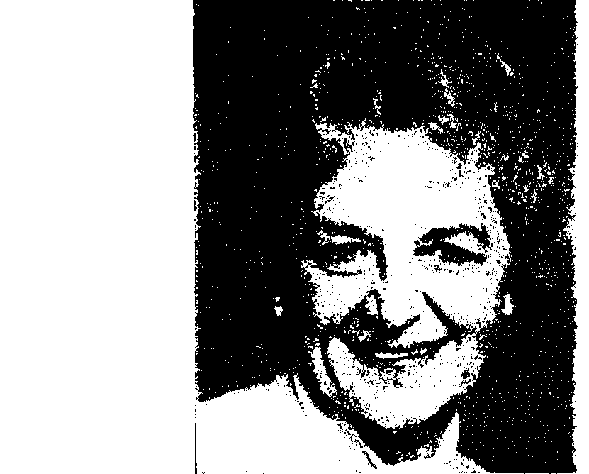
By JOY FOX – Cranston Herald, March 2001
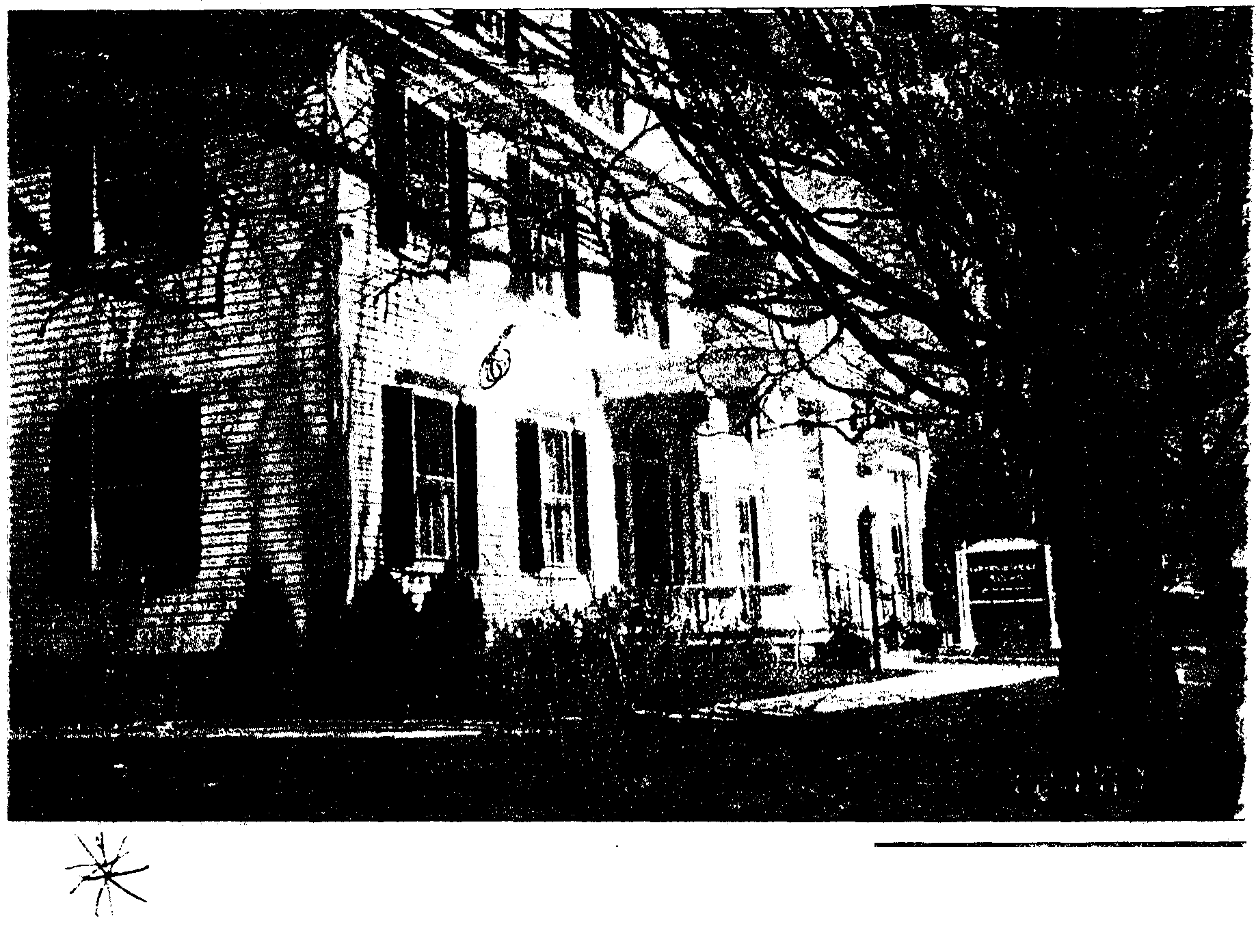
Forever charming
The Sprague Mansion (pictured right) was preserved mostly due to the efforts of Viola Lynch (at left).
The majestic Sprague Mansion, located at 1351 Cranston St., was _once in serious danger of a date with the wrecking ball that is, until Viola Lynch received a call in 1966 from a friend in the city clerk's office warning her about the impending plans to demolish the building, according to her husband, Robert Lynch.
"That warning was all Viola needed to hear," said Lynch. From then on, there was no delay, no hesitation. Sprague Mansion had to be saved.
Saving the mansion was a natural progression for the couple, as they were active in the Cranston Historical Society.

"In 1957 they played a major role in saving and restoring the Joy Homestead on Scituate Avenue," said their son, Robert.
The Historical Society at the time had no headquarters or place to hold its monthly meetings, according to Lynch, who remembers attending meetings in the City Hall council chamber.
"Viola and I found out that the farmhouse was going to be sold. We thought the society needed something to strive for," said Lynch. So, after the formation of a building committee and a brief period of looking for a site, the society purchased the Joy Homestead. "We always thought the committee was going to choose the homestead," said Lynch. The society raised approximately $4.000 for the homestead.
Saving the Joy Homestead would prove to be a small accomplishment in comparison to the mansion.
"We got everyone happily steamed up," said Lynch about involving the comm.unity in preserving Sprague Mansion. Viola soon became the spokesperson for the effort to save the mansion.
She started the drive to save Sprague. It was a last-ditch effort to preserve the building," said Betty Miller, a longtime friend of Viola's and a society member.
"Quite frankly, we needed to set up some basic principles that would involve the community, something more than just saving a building," said Lynch.
It was decided to position the mansion as the community's center.
"At the time, we had many little neighborhoods in the city but no focal point," said Lynch "We figured this would a good place for various meetings and to create a structure that could cover the entire community."
Everyone got involved, according to Lynch High school kids were even enlisted in the cause, collecting money and conducting polls in the community as to whether or not this was an important issue.
The first major problem that had to be taken care of was to stop the federal government's plans to redevelop the site for elderly housing.
"We were able to get them to put a hold on their plans, and this secured time," said Lynch.
Not much time, however. The society and the community were only given 30 days to come up with the funds to save the building.
The second task was fundraising.
"The question was, how were we going to raise $125,000? We had a committee in charge of fundraising, the CYO held dances, we collected newspapers and some churches even asked for money during their weekly collections," said Lynch. "It was fully remarkable."
The first donation came from the Rockefellers, according to Lynch.
"They also owned the Print Works next door, and had used the mansion to house their plant supervisor," said Lynch. Their $5,000 donation got the campaign started.
Throughout all this activity, Viola was in the middle, leading the charge.

"We had a lot of good solid citizens helping, but Viola was the prime mover and shaker. She was the face we presented to the public to represent the mansion," said Lynch.
"There is a funny story about the first time Viola and the other ladies met with the mayor about saving the building," said Lynch. "Supposedly, someone called the mayor back from a conference in Washington, D.C., by saying that there were a whole bunch of angry preservationists up here.
When the mayor finally arrived, he laughed and said from the message he was expecting to be accosted by big or battleaxes. Instead, what he found were four ladies armed with dignity, grace and charm," said Lynch.
By the time Viola was done, the city ended up helping to save Sprague.
"That was how she did things, with charm, never confrontation," said Lynch.
Looking back, Lynch believes the organizers went down a logical path to save the mansion.
"We were able to get the federal government to hold their plans. We were highly supported in the public opinion polls. From a political standpoint, it became obvious to officials it would be better for them to change course," said Lynch.
In the end the organization was able to accomplish exactly what it set out to do.
"We achieved our objective, and today the mansion is still a place for meetings and parties," said Lynch.
The board of management that was originally created to help save the mansion is still running the daily operations of Sprague Mansion today.
"Viola and Bob were definitely in the forefront of saving Sprague," said Miller.
Viola was also very dynamic beyond the Cranston Historical Society. In 1952 she founded the Cranston Junior Women's Club.
"We would always be looking for good causes to help in the community" said Miller.
"Viola was always looking ahead. She could infect a person with her enthusiasm," said Miller.
Viola Lynch, who passed away on March 13 after a battle with cancer, will always be remembered by family and friends as a "visionary and a crusader."
Viola was born in Warren, Rhode Island, on Aug. 20, 1922, and grew up in Cranston. She attended the Valentine Almy School, Briggs and Cranston High School.
"It was at Cranston High School that she met her future husband, Robert Lynch of Edgewood," said Robert. "Their romance blossomed and they were married at St. Matthew's Church on April 10, 1944."
She and her husband raised two sons Robert Porter Lynch and Richard Allen Lynch. In 1991, Viola and Bob bought and managed the Nathaniel Porter Inn in Warren from their son, Robert.
"My mother lived her life full of grace and always gave in large measure, expecting so little in return," said Robert. "The world is a better place because of her spirit."

